Recommended improvements to BS8462 – maximum weight for children’s goals

Topple Dangers Posed By Free-standing Soccer Goalposts Report
(Pedgley, Haake. 2002)
- In 2002 ITS A GOAL Ltd. commissioned this report by University of Sheffield
- Publicly available information
- Available for goalpost manufacturers for over ten years
- Presented to the British Standards Institute

Conclusion of Report
- Mass of goalpost is a major issue
- Basis for Its A Goal goalpost innovation
- Maximum safe weight is recommended

The Aim
To find a maximum safe weight for children and youth freestanding football goalposts, up to and including 21’x7” (6.4x2.1m)

Empirical Research
“A goal may collapse as the result of someone hanging on the crossbar, during recreational play, when the goal is moved, or from a gust of wind, and only rarely in relation to a match” (Blønd, Hansen,. 1999)

Empirical Research
- Accidents happen when goals are being put up, taken down or in storage
- Back bar weight increases manoeuvrability problems
- Heavy individual sections will be dangerous and should be less than 25kg for lifting safety
- Maximum safe weight for children and youth’s freestanding football goalposts needs to be determined

Blunt Thoracic Trauma In Children: Review of 137 Cases
(Balci et al. 2004)
- Blunt injuries sustained to the chest cavity
- Generally from a fall or road accident
- Injuries to other parts of the body can also occur from such an incident
- Often results in hospitalisation

Blunt Thoracic Trauma Data
- “The mean age of children was 6.9 +/- 7.3 (1-16) years. Of the patients, 19.7% (n:27) were under 5 and 52% (n:70) were between 9 and 12 years ” (Balci, et al.)
- This is the data the following calculations are based on.
- Please note, a child under the age of 9 wouldn’t be able to withstand the same force as a child over the age of 12. The different age group tolerances need to be considered.

Kinetic energy and ISS relationship in children with thoracic and associated injuries. (Balci, et al. 2004)

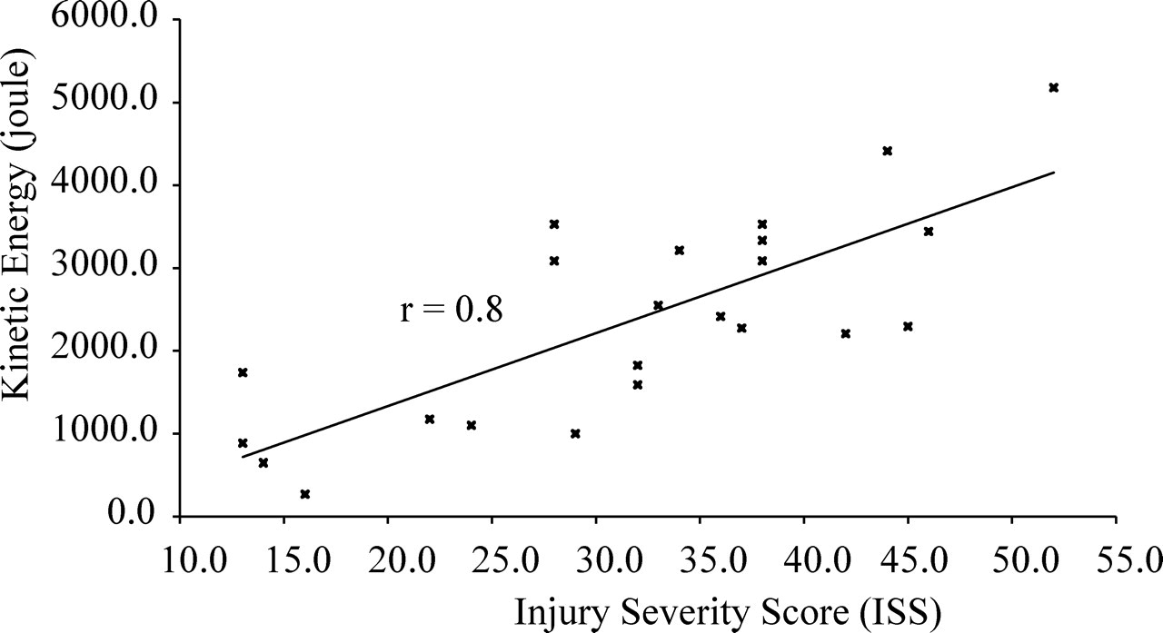

Injury Severity Score & Abbreviated Injury Scale
- An ISS score of 12 is equivocal to 3 injuries at AIS score 2 (moderate)
- The victim would be expected to survive and not be severely injured.
- Using ISS score 12 as a maximum, from the graph this gives a kinetic energy value of around 600 Joules
E_{K} = 600J

Kinetic Energy
Kinetic energy is the energy of an object in motion
E_{K} = 0.5 mv²

E_{K} Kinetic energy
m Mass of an object
v Velocity at which the object is moving

Velocity
- Velocity is the rate of change of displacement in unit time.
- Distance covered by the crossbar, the height from a 16x7ft (2.13m) goalpost
- Average time taken to fall 0.4 seconds
(Pedgley, Haake. 2002)
v = d / t
v = 2.13 / 0.4
v = 5.325ms⁻¹

Calculation
- Kinetic energy equation: E_{K} = 0.5 mv²
- Rearranging gives: m = E_{K} / 0.5 v²

- Known values: v = 5.325ms-1
E_{K} = 600J

- Inputting the values gives: m = 600 / 0.5 x 5.325²
mass = 42.32 kg (2 d.p.)

Heavier Goalposts
- The weight or potential injury of any goal can be calculated in this way
- Following the previous method a goalpost of 70kg would result in several serious injuries. The victim would be hospitalised but it is unlikely they would die from the injuries, unless they were very young.
- However an even heavier goalpost would result in severe and critical injuries, and it may be un-survivable.

Results
  - 1-18kg no risk
  - 18-42kg slight risk
  - 42-54kg high risk
  - 54-70kg very high risk
  - 70-98kg potentially un survivable

Conclusion
From the data used in this investigation, 42kg has been found as the guideline value for a maximum safe weight for children and youth freestanding football goalposts, up to and including 21’x7” (6.4x2.1m)

Additional Recommendations
- Definition of goalpost and difference between adult and children’s goalposts
- Information from standard available to clubs
- Dangerous goalposts could be condemned by an approved inspectorate
- Grant scheme available to replace freestanding goalposts used by children that are above the maximum safe weight limit
- Warning labels to be applied to full sized adult goalposts above the maximum safe weight limit
- A maximum weight per meter of post sections be agreed as a total weight in a reduced mass area may still create impact injury.

References
- Balci A, et al. (2004) Blunt thoracic trauma in children: review of 137 cases. European Journal of Cardio-thoracic Surgery 26. 387-392.
- Baker SP, et al (1974) The injury severity score: A method for describing patients with multiple injuries and evaluating emergency care. The Journal of Trauma. 14. 3. 187-196
- Blønd L. Hansen LB. (1999) Injuries caused by falling soccer goalposts in Denmark. British Journal of Sports Medicine. 33. 110 - 112
- Charlton HR. (2012) Maximum safe weight for children’s goalpost calculation.
- Pedgley O. Haake S. (2002) Topple dangers posed by free-standing soccer goalposts. Sports Engineering 5. 53-63
- Score GC. (1995 revised 2001) Injury severity scoring. <www.surgicalcriticalcare.net/Resources/injury_severity_scoring.pdf> Last accessed 7/8/2012

Appendix
42kg is a good place to begin when calculating a maximum safe weight for goalposts being used by children especially aged 9-12. The melon test used by Its A Goal clearly indicated that lighter goalposts are safer. As a further extension of this calculation the density of the material will also be a variable factor that could be used to give a more specific value. This would allow each goalpost of a certain size and material to have a maximum safe mass, depending on the age range of the children intending to use it. The problem with this would be that you could never guarantee that all the variables will be correctly fulfilled when toppling does occur. There would be external factors that would be difficult to account for, such as extreme weather conditions. A limit would have to be introduced otherwise the data would become so specific that it become redundant.

This is why we work as hard as we do to change the standards to make sure heavy steel goalposts are removed from the UK …..visit and find out about the last accident in 2012

http://www.bbc.co.uk/news/uk-wales-mid-wales-20026020 Copyright J R Wilson 2012

